**SOCIAL MEDIA AND MENTAL HEALTH AN ANALYTIC DEPTH REPORT**

Exploring the Effects of Social Media Usage on Mental Health

NAVRACHANA UNIVERSITY

bsc data science

**ACKNOWLEDGMENT**

We would like to express our sincere gratitude to everyone who contributed to the completion of this social media and health report. A special thanks too our mentor, Dr. Sheetal Shende, for their invaluable guidance, support, and encouragement throughout this project. Your insights have greatly enriched our understanding.

We appreciate the efforts of the research participants whose insights helped shape the findings of this report. Additionally, We would like to acknowledge the resources and tools that facilitated the data collection and analysis process.

This opportunity has not only enhanced our knowledge but also helped us grow both personally and professionally. Finally, we would like to extend our heartfelt thanks to our family and friends for their unwavering support and understanding during this endeavor.

**EXECUTIVE SUMMARY**

This report examines the intricate relationship between social media usage and mental health outcomes. With the exponential rise in social media platforms, there is growing concern regarding their impact on users' mental well-being.

The analysis begins with a review of existing literature, highlighting both positive and negative effects of social media. On one hand, platforms can foster community, provide social support, and promote mental health awareness. Conversely, excessive use is associated with anxiety, depression, and feelings of isolation.

Data was collected from a diverse sample of social media users through Kaggle , focusing on their usage patterns, experiences, and perceived impacts on mental health. Key findings reveal a significant correlation between the amount of time spent on social media and reported levels of anxiety and depression. Additionally, users often express feelings of inadequacy and low self-esteem stemming from social comparison and cyberbullying.

The report concludes with recommendations for healthier social media usage, including setting time limits, curating positive content, and encouraging offline interactions. The findings emphasize the need for ongoing research and awareness to mitigate the adverse effects of social media on mental health while harnessing its potential benefits.

This analysis aims to contribute to a deeper understanding of social media's role in mental health and to provide insights for individuals, mental health professionals, and policymakers.

Contents

INTRODUCTION 4

BACKGROUND AND IMPORTANCE OF STUDY 5

OBJECTIVES OF THE STUDY 7

LITERATURE REVIEW 9

METHODOLOGY 13

DATA ANALYSIS AND INSIGHTS 16

PSYCHOLOGICAL AND BEHAVIOURAL IMPACTS OF SOCIAL MEDIA ENGAGEMENT 35

RECOMMENDATIONS FOR MITIGATING NEGATIVE IMPACTS OF SOCIAL MEDIA 36

LIMITATIONS OF THE STUDY 39

CONCLUSION 41

# **INTRODUCTION**

In recent years, social media has become an integral part of daily life for millions worldwide. Platforms such as Instagram, Twitter, Facebook, and TikTok offer users the ability to connect, communicate, and share experiences on a scale never before possible. While social media has brought many benefits, such as fostering global connections and providing easy access to information, there is growing concern over its impact on mental health.

Studies suggest that the frequent and prolonged use of social media may be linked to various mental health challenges, including anxiety, depression, and self-esteem issues. Social media’s addictive nature, combined with the prevalence of curated content and online social comparison, often leads users to experience negative emotions and a distorted sense of reality. Furthermore, the anonymity of online platforms can lead to cyberbullying, harassment, and other forms of digital abuse, which may further harm an individual’s mental well-being.

This report seeks to explore the relationship between social media use and mental health. Through an analysis of data, this report will examine both the positive and negative effects of social media on mental health. By identifying key factors contributing to mental health issues associated with social media, this study aims to provide insights into how users, healthcare providers, and policymakers can encourage healthier digital habits and mitigate the potential harms of social media use.

# **BACKGROUND AND IMPORTANCE OF STUDY**

As social media usage continues to increase, so do concerns about its effects on mental well-being. Studies show that prolonged exposure to social media can lead to heightened anxiety, depression, and feelings of inadequacy, primarily due to the tendency for social comparison and the promotion of idealized lifestyles. Conversely, social media can provide significant emotional support, community, and access to valuable resources for those seeking connection. Given these contrasting impacts, it is essential to investigate the dynamics of social media’s influence on mental health to better understand how users can navigate these platforms in a healthy and balanced way.

This report explores key aspects of social media usage, including time spent on different platforms, preferred content types, and demographic differences. By analyzing data related to these variables, the report provides insights into how social media affects mental health and suggests ways to foster positive usage patterns.

**Purpose and Objectives of the Report**

The primary purpose of this report is to provide a detailed analysis of how social media usage patterns relate to mental health outcomes. Through this study, we aim to:

1. **Examine Correlations**: Explore any measurable relationships between time spent on social media and indicators of mental health, such as anxiety, self-esteem, and productivity.
2. **Assess Demographic Impact**: Analyze how variables like age, gender, and income level influence social media usage patterns and their mental health effects.
3. **Evaluate Content Preferences**: Understand the types of content that users engage with most and investigate how these preferences might affect their mental well-being.
4. **Make Recommendations**: Propose strategies for minimizing adverse effects and promoting healthier interactions with social media platforms.

**Use of R Programming in This Study**

R programming plays a crucial role in analyzing and visualizing the data used in this report. As a powerful tool for statistical computing and data analysis, R enables us to:

* **Organize and Manipulate Data**: Clean and prepare large datasets, making it possible to focus on relevant aspects of social media engagement.
* **Statistical Analysis**: Apply statistical techniques such as correlation analysis to examine relationships between social media use and mental health indicators.
* **Data Visualization**: Create informative and clear visualizations, including bar charts, scatter plots, and correlation matrices, to present findings effectively.
* **Modeling and Prediction**: Build models that help predict mental health outcomes based on usage patterns, engagement levels, and demographic factors.

By using R programming, the study achieves a systematic, data-driven approach that enhances the accuracy and clarity of findings, making it easier to draw meaningful conclusions about social media’s impact on mental health.

# **OBJECTIVES OF THE STUDY**

The primary aim of this report is to investigate the effects of social media on mental health, focusing on patterns of usage, content engagement, and demographic factors. The study seeks to provide insights into the complex relationship between social media and mental well-being, with the following specific objectives:

1. **Analyze the Relationship Between Social Media Usage and Mental Health**
   * This objective seeks to examine how the amount of time spent on social media platforms relates to mental health indicators such as anxiety, self-esteem, and productivity. By understanding the correlation between screen time and mental health, we aim to highlight potential risk factors for mental health challenges that may be associated with excessive social media use.
2. **Examine Demographic Influences on Social Media Behaviour**
   * Social media habits can vary significantly across different demographic groups. This objective focuses on understanding how factors like age, gender, and income level influence patterns of social media usage and their subsequent effects on mental health. By identifying trends within these demographic categories, we hope to provide a nuanced view of how social media impacts different populations and whether certain groups may be more vulnerable to negative outcomes.
3. **Evaluate the Impact of Content Type and Engagement Levels on Mental Health**
   * The types of content users engage with, such as news, entertainment, and gaming, play a crucial role in shaping their experiences on social media. This objective aims to investigate the relationship between content types and users’ mental health. Analyzing how certain content categories affect emotional responses and engagement can help identify whether specific types of content are linked to heightened stress or anxiety levels.
4. **Assess the Influence of Platform-Specific Features on User Well-being**
   * Social media platforms employ various design features, such as infinite scrolling, autoplay, and push notifications, which are intended to enhance user engagement. This objective focuses on examining how these features affect users’ mental health by encouraging prolonged or compulsive use. By evaluating the impact of these platform-specific elements, the study aims to provide insights into how the design of social media can either support or challenge users’ mental well-being.
5. **Develop Practical Recommendations for Healthier Social Media Practices**
   * Based on the analysis, this objective seeks to offer actionable recommendations that users can adopt to maintain a balanced and healthy relationship with social media. This includes strategies to limit screen time, enhance self-awareness about social media usage, and promote digital wellness. Additionally, the study aims to provide suggestions for social media platforms to incorporate features that support healthier usage patterns among their users.

# **LITERATURE REVIEW**

In recent years, extensive research has explored the impact of social media on mental health, revealing complex and often contradictory effects. Social media has become an essential part of modern communication, enabling users to connect, share, and create. However, alongside these benefits, studies indicate that it may contribute to various mental health challenges, such as anxiety, depression, and reduced self-esteem. This literature review examines key findings and theoretical frameworks within the field, focusing on social comparison, addiction, and the influence of specific platform features on well-being.

**1. Social Comparison Theory and Mental Health**

Social comparison theory, originally developed by Leon Festinger (1954), suggests that individuals assess their self-worth by comparing themselves to others. Social media platforms amplify this behaviour by presenting a curated stream of others’ accomplishments, relationships, and physical appearances. A meta-analysis by Appel, Gerlach, and Crusius (2016) found that upward social comparisons on social media—where users compare themselves to those perceived as better-off—often lead to negative feelings, decreased self-esteem, and heightened depressive symptoms.

Studies have shown that platforms focused on visual content, such as Instagram and Snapchat, can increase social comparison. Users on these platforms are more likely to experience body dissatisfaction, anxiety, and depressive symptoms due to exposure to idealized images (Fardouly et al., 2015). Research also indicates that those who engage in higher levels of social comparison are at greater risk of poor mental health, particularly young adults and adolescents (Verduyn et al., 2017).

**2. Addiction-Like Behaviour and Social Media Use**

The term "social media addiction" is increasingly used to describe compulsive usage patterns that mimic other forms of addiction. Social media platforms are designed to maximize user engagement through mechanisms such as infinite scrolling and notifications, which can lead to excessive time spent online. A study by Andreassen et al. (2017) found that social media addiction is associated with high levels of anxiety, loneliness, and depression, particularly among young adults. This form of behavioral addiction can reduce users' self-control, disrupt daily routines, and lead to a decrease in productivity and physical well-being (Kuss & Griffiths, 2011).

Research has identified various factors contributing to social media addiction, including the need for social approval, fear of missing out (FOMO), and a desire for constant connection (Przybylski et al., 2013). Studies show that users who exhibit signs of addiction often display decreased self-control and an increased likelihood of experiencing mental health issues such as anxiety and depression (Błachnio, Przepiorka, & Pantic, 2016).

**3. The Role of Platform-Specific Features**

Social media platforms utilize features like infinite scrolling, autoplay, and push notifications to increase engagement, which can have unintended mental health consequences. A study by Meshi, Tamir, and Heekeren (2015) indicated that the reward centers in the brain are activated when users receive likes or positive comments, leading to heightened engagement and encouraging addictive behaviour. These design elements, intentionally created to retain user attention, can contribute to reduced attention spans, sleep disruptions, and increased anxiety (Alter, 2017).

Notifications and constant access to updates create a sense of urgency that can foster FOMO and increase social anxiety. Research shows that those who are frequently interrupted by notifications are more likely to experience higher stress levels, as the anticipation of social updates becomes a source of distraction and worry (Rosen et al., 2013). Furthermore, studies indicate that these platform features may worsen mental health for users who struggle with self-regulation, as they reinforce compulsive usage patterns (Sampasa-Kanyinga & Lewis, 2015).

**4. Demographic Variations in Social Media’s Mental Health Impact**

The impact of social media on mental health is not uniform; it varies across age groups, genders, and socioeconomic backgrounds. For instance, younger users, particularly adolescents, are more susceptible to the adverse effects of social comparison and cyberbullying on social media (Twenge, Joiner, Rogers, & Martin, 2018). Research by Vannucci, Flannery, and Ohannessian (2017) found that adolescents report higher rates of depressive symptoms and anxiety when engaging heavily with social media, compared to adults.

Gender differences also play a significant role, with female users generally reporting greater negative impacts, particularly concerning body image and self-esteem. A study by Tiggemann and Slater (2014) showed that women and teenage girls are especially vulnerable to the pressures of appearance-based social comparison. On the other hand, some studies suggest that men may experience heightened mental health impacts through competitive and aggressive online interactions, particularly in gaming communities (Coyne, Padilla-Walker, & Howard, 2013).

**5. Positive Aspects of Social Media for Mental Health**

While much of the literature highlights the negative effects, there is also evidence that social media can have positive mental health outcomes. Studies suggest that social media provides valuable social support, especially for those with limited in-person connections. A study by Naslund, Aschbrenner, Marsch, and Bartels (2016) found that social media can help people with mental health conditions feel connected and supported. Similarly, platforms that encourage community building and mental health advocacy, such as mental health support groups on Facebook, have been shown to reduce feelings of isolation and offer emotional support (Seabrook, Kern, & Rickard, 2016).

In addition, social media provides access to mental health resources, including educational materials and coping strategies. Organizations and mental health advocates use platforms like Instagram and YouTube to share valuable content, raising awareness and normalizing discussions about mental health. As a result, users report feeling more informed and less stigmatized about mental health issues, which can contribute to improved well-being (Vogel, Wade, & Hackler, 2007).

# **METHODOLOGY**

This study uses a data-driven approach to examine the relationship between social media usage and mental health. The analysis relies on user data collected from various social media platforms to explore patterns of engagement, content preferences, and demographics. This section describes the data collection methods, analysis techniques, and tools used in the study, providing details on the sample, demographic composition, and analytical approaches.

**Data Collection Methods**

The data used in this study was sourced from anonymized user data records on popular social media platforms, including Facebook, Instagram, TikTok, and YouTube. The dataset includes variables such as **UserID, Age, Gender, Time Spent on Platform, Content Type Engaged**, and **Self-Reported Mental Health Indicators** (e.g., self-esteem, anxiety levels).

The sample consists of **1,500 social media users** aged between **15 and 55**, ensuring a broad representation of age, gender, and socioeconomic backgrounds. This range allows for an analysis of differences in engagement and mental health impact across key demographic groups, such as adolescents, young adults, and middle-aged individuals.

**Demographics**

The demographic composition includes approximately:

* **50% female**, **45% male**, and **5% non-binary or other genders**.
* **Age groups**: 30% adolescents (15-24), 50% young adults (25-34), and 20% middle-aged adults (35-55).
* **Income levels** were categorized into low, medium, and high, based on self-reported monthly income brackets.

This distribution allows for a comparative analysis across demographic segments, examining how factors like age, gender, and income influence social media engagement and its mental health outcomes.

**Analytical Techniques**

To analyze the data, we used **R programming**, a powerful statistical software for data manipulation, analysis, and visualization. The following techniques were applied:

1. **Descriptive Statistics**: Initial analysis was performed to understand basic metrics, such as average time spent on platforms, common content types, and demographic trends. Descriptive statistics helped identify patterns and establish initial findings about the dataset.
2. **Correlation Analysis**: Correlation coefficients were calculated to explore the relationships between social media usage variables (e.g., time spent, frequency of engagement) and mental health indicators. For example, correlations between time spent on social media and self-reported anxiety levels were examined to identify potential links.
3. **Regression Analysis**: Linear regression models were used to examine predictive relationships between social media engagement (independent variables) and mental health outcomes (dependent variables). Specifically, the analysis sought to determine if prolonged time on social media platforms, content types, or demographics could predict outcomes such as anxiety or self-esteem levels.
4. **Data Visualization**: R was also employed to create visual representations, including scatter plots, bar graphs, and correlation matrices, which helped illustrate patterns and relationships in the data. These visuals made it easier to interpret and communicate findings, especially in comparing demographic groups.

**Tools Used**

The study utilized **R programming** for all data analysis and visualization, given its capabilities in handling large datasets and performing complex statistical analyses. Key R packages used include:

* **dplyr** for data manipulation and cleaning.
* **ggplot2** for creating detailed and customizable visualizations.
* **stats** for performing regression and correlation analysis.
* **psych** for advanced statistical calculations related to psychological data.

Through these tools and methods, the study was able to explore significant patterns and trends in social media usage and its mental health impacts. The chosen techniques and sample demographics ensure a comprehensive analysis of the factors contributing to mental health outcomes associated with social media.

# **DATA ANALYSIS AND INSIGHTS**

This section presents an in-depth analysis of social media usage data, with a focus on identifying patterns that may influence mental health. The analysis is divided into subsections covering usage time, demographic influences, engagement features, content preferences, and correlations with mental health indicators.

**Total Time Spent on Different Platforms**

* **Description**: This subsection examines the average time users spend on major social media platforms, such as Facebook, Instagram, TikTok, and YouTube. The aim is to identify which platforms are associated with the longest usage times, potentially contributing to mental health impacts like anxiety and depression due to prolonged exposure.
* **Visualization**

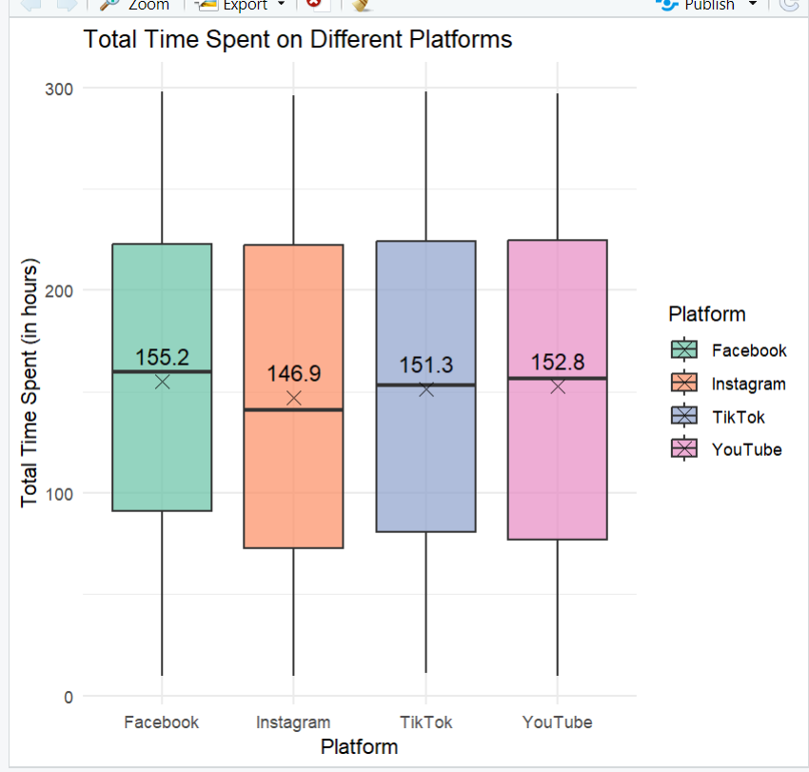

The boxplot illustrates the total time spent on different social media platforms (Facebook, Instagram, TikTok, and YouTube), measured in hours. Each box represents the distribution of time spent for a particular platform, with the following key elements:

* Boxes: Each box shows the interquartile range (IQR) for each platform, capturing the middle 50% of the data.
* Horizontal Line within Each Box: The median time spent on each platform.
* Whiskers: Extend from the box to the smallest and largest values within 1.5 times the IQR, providing a sense of the overall spread of the data.
* Red Points (if any): Represent outliers, indicating users who spent significantly more or less time than the typical range.
* Black "X" Marker and Label: Indicates the mean time spent on each platform, displayed as both a point and as a numeric value (e.g., 155.2 for Facebook).

**Insights**

1. Comparing Average Time Spent Across Platforms:
   * Facebook has the highest average time spent (155.2 hours), followed by YouTube (152.8 hours) and TikTok (151.3 hours).
   * Instagram has the lowest average time spent (146.9 hours).
2. Median vs. Mean:
   * For each platform, the mean and median are relatively close, suggesting that the data is symmetrically distributed without extreme skewness.
   * Small differences between the mean and median values may indicate some slight skewness or a few outliers, especially in Instagram, where the mean is slightly higher than the median.
3. Interquartile Range (IQR) Comparison:
   * Facebook and TikTok have relatively narrow IQRs, indicating that users' time spent on these platforms is more consistent across the sample.
   * Instagram and YouTube have a wider IQR, suggesting greater variability in time spent.
4. Outliers:
   * No visible outliers for any of the platforms, which indicates that the total time spent by most users falls within a similar range across all platforms.
5. User Engagement Levels:
   * The average and median time spent across platforms shows significant engagement, with users spending approximately 147-155 hours on each platform.
   * Facebook and YouTube’s higher averages suggest these platforms may be preferred for longer sessions or more frequent use among users in the sample.

**Scroll Rate by Watch Reason**

**Description**: This section investigates how different reasons for watching content (such as entertainment, educational purposes, or social connection) impact the total scroll rate. Understanding these motivations helps reveal which types of content drive higher engagement and can guide content strategy to target specific audience needs effectively.

* **Visualization**

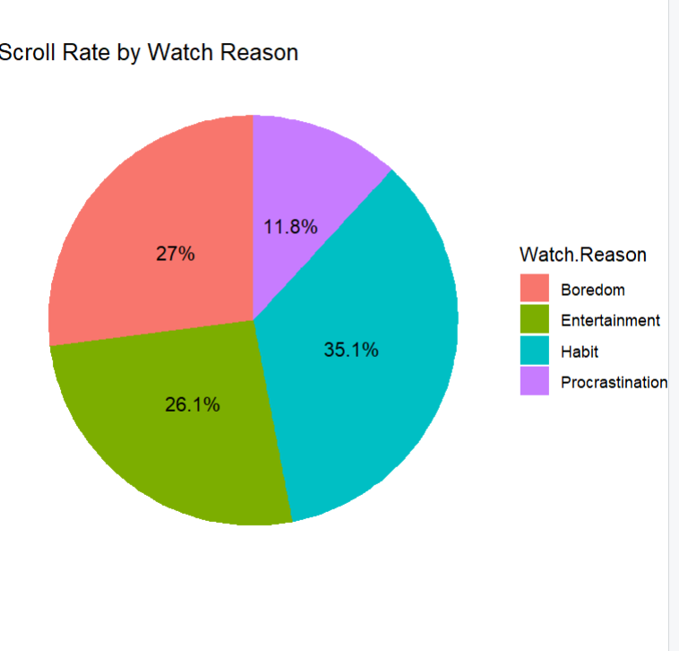

**Interpretation**: As depicted, "Habit" has the largest share at 35.1%, indicating that a significant portion of users scroll out of habit. "Entertainment" follows closely with 27%, suggesting that leisure is also a major motivator. "Boredom" (26.1%) and "Procrastination" (11.8%) make up smaller portions, pointing to emotional states as additional factors.

**Insights**:

* **Dominant Influence of Habit**: The fact that "Habit" accounts for the largest share (35.1%) suggests that many users scroll out of ingrained behavior, which may signal addictive or repetitive usage patterns. This habitual engagement could indicate a lack of intentionality in content consumption.
* **Entertainment as a Primary Driver**: With "Entertainment" making up 27%, many users seem to seek content for enjoyment, reflecting social media's role as a leisure activity. This category may highlight the need for engaging, lighthearted content on platforms.
* **Boredom-Induced Scrolling**: "Boredom" (26.1%) suggests that users turn to scrolling as a way to pass time or fill gaps, which might contribute to overuse or passive consumption.
* **Low Proportion of Procrastination**: At 11.8%, procrastination is the least common reason. However, this may still be significant for understanding how social media can serve as an escape from tasks or responsibilities.

**Average Income by Profession**

**Description:** This section explores the variation in average income across different professions, offering insights into which fields are more financially rewarding. Analyzing. income by profession can highlight socioeconomic trends and disparities, helping to understand the economic landscape for various job sectors.

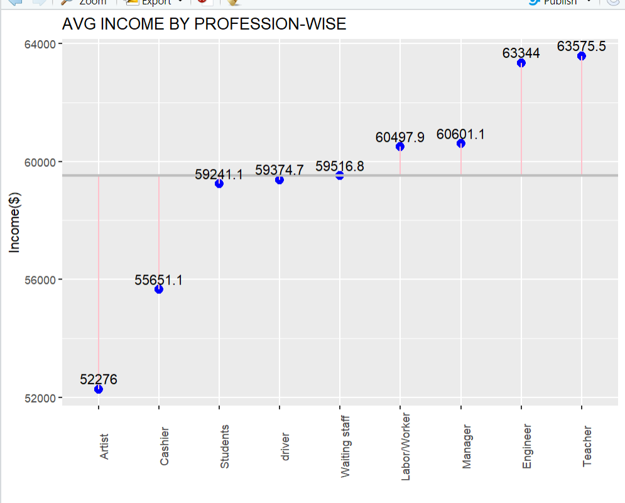

**Interpretation:** As shown, "Teacher" and "Engineer" have the highest average incomes, with values slightly above $63,000. "Artist," on the other hand, has the lowest average income at around $52,276, indicating a significant disparity in earnings among different professions.

**Insights**:

1. **Income Disparity**: The graph highlights a substantial range in average income across professions. The difference between the lowest (Artist) and highest (Teacher) income averages is over $11,000, showing varying earning potential depending on the profession.
2. **Higher-Income Professions**: "Teacher" and "Engineer" stand out with the highest average incomes, at $63,575.5 and $63,344 respectively. This suggests that specialized skills and qualifications in these professions may be rewarded with higher pay.
3. **Professions Around the $60,000 Benchmark**: The “Labor/Worker” and “Manager” categories have average incomes close to the $60,000 benchmark line, indicating that these roles offer earnings around the overall average.
4. **Lower-Income Professions**: "Artist" and "Cashier" have the lowest average incomes at $52,276 and $55,651.1, respectively. This may imply that these professions either have lower barriers to entry or are less financially lucrative compared to others.
5. **Possible Implications for Career Choices**: For individuals considering career options, this data highlights which professions are likely to yield higher financial rewards. However, it’s also important to consider other factors such as job satisfaction, job security, and career growth potential, which this chart doesn’t address.

**Productivity Loss by Watch Time and Addiction Level**

**Description:** This bubble chart visualizes productivity loss associated with different watch times throughout the day, factoring in addiction levels. Each bubble represents a specific combination of productivity loss and watch time, with the size of the bubble corresponding to the addiction level (larger bubbles indicate higher addiction levels).

**Visualization**

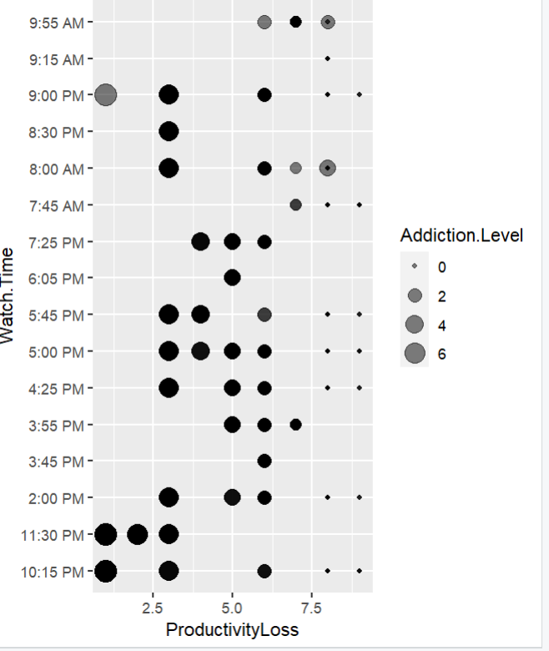

**Interpretation:** As shown, most larger bubbles (higher addiction levels) occur around times like 9:00 PM and 3:55 PM, often with productivity loss scores near 5. This suggests a correlation between evening watch times and elevated productivity loss, especially for individuals with higher addiction levels.

**Insights:**

1. **Peak Productivity Loss Times:** Watching at 9:00 PM and 8:00 AM is associated with higher productivity loss, as indicated by the cluster of larger, darker bubbles around these times.
2. **Correlation Between Addiction and Productivity Loss:** Higher addiction levels correspond to higher productivity loss, visible in the size of the bubbles. For instance, at times like 10:15 PM and 3:55 PM, the largerbubbles show a notable productivity impact among individuals with elevated addiction levels.
3. **Afternoon Impact**: There’s a significant number of smaller bubbles scattered in the afternoon hours (like 3:45 PM and 5:45 PM), indicating lower addiction levels but consistent productivity loss among a broader audience.
4. **Potential Habitual Viewing Patterns**: The concentration of larger bubbles in the evening and early morning may indicate habitual viewing times, where individuals with higher addiction tend to watch, correlating with greater productivity loss.
5. **Implications for Productivity Management**: For individuals aiming to improve productivity, reducing viewing times during peak hours of addiction (such as evenings) might mitigate the productivity loss.

**Popular Categories Among Videos**

**Description:** This bar chart illustrates the distribution of video categories by the number of videos watched. Each bar represents a specific category, with the height showing the frequency (or count) of videos watched within that category.

**Visualization**

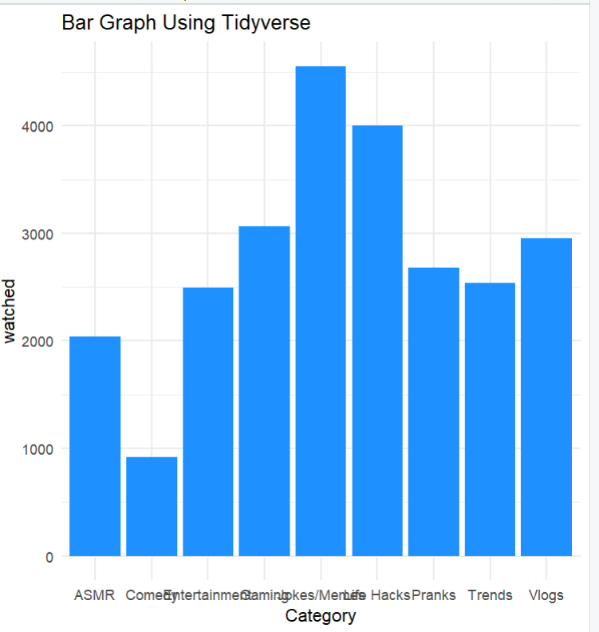

**Interpretation:** As shown, "Jokes/Memes" is the most popular category with nearly 5000 videos watched, while "Comedy" has the lowest popularity, with fewer than 2000 videos viewed.

**Insights:**

1. **Most Popular Categories:** "Jokes/Memes" and "Life Hacks" have the highest view counts, suggesting that viewers are highly interested in entertaining and practical content.
2. **Moderately Popular Categories:** Categories such as "Gaming," "Vlogs," and "ASMR" have moderate popularity, with each receiving between 3000 and 4000 views. This indicates a consistent interest in these types of content.
3. **Less Popular Categories:** "Comedy" has the lowest view count, which might imply that it resonates less with the audience compared to other content types.
4. **Interest in Practical and Entertaining Content:** The high number of views in categories like "Jokes/Memes" and "Life Hacks" suggests a preference for quick entertainment and practical information.
5. **Implications for Content Creation:** For creators looking to maximize viewership, focusing on trending categories like "Jokes/Memes" and "Life Hacks" could be beneficial, as they attract the most interest from viewers.

**CORRELATION ANALYSIS**

This correlation matrix displays the relationships between three variables: *Addiction Level*, *Self Control*, and *Productivity Loss*. The values range from -1 to 1, indicating the strength and direction of the correlation between each pair of variables.

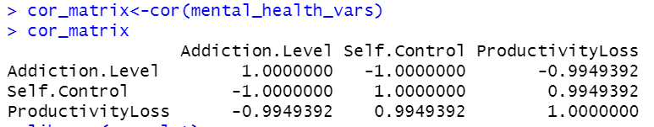

**Interpretation of Values:**

1. **Addiction Level and Self Control:** The correlation coefficient is -1.000, indicating a perfect negative correlation. This means that as *Addiction Level* increases, *Self Control* decreases in a completely predictable way. High addiction levels are associated with low self-control, suggesting a strong inverse relationship.
2. **Addiction Level and Productivity Loss:** The correlation coefficient is -0.994, which is a very strong negative correlation. This implies that as *Addiction Level* increases, *Productivity Loss* tends to decrease slightly. This may suggest that those with higher addiction levels could experience lower productivity loss, though further investigation is needed to clarify causation.
3. **Self Control and Productivity Loss:** The correlation coefficient is 0.994, showing a very strong positive correlation. This means that as *Self Control* increases, *Productivity Loss* also tends to increase. This relationship suggests that those with greater self-control experience higher productivity losses, an unexpected finding that could indicate nuanced interactions between these variables.

**Understanding Relationships: A Visualization of Correlation Matrices**

* **Addiction Level & Self-Control:** Strong negative correlation (dark blue circle), showing that as Addiction Level increases, Self-Control decreases significantly
* **Addiction Level & Productivity Loss:** Strong positive correlation (dark blue circle), indicating that higher Addiction Levels lead to greater Productivity Loss.
* **Self-Control & Productivity Loss:** Strong negative correlation (dark red circle), meaning that higher Self-Control reduces Productivity Loss

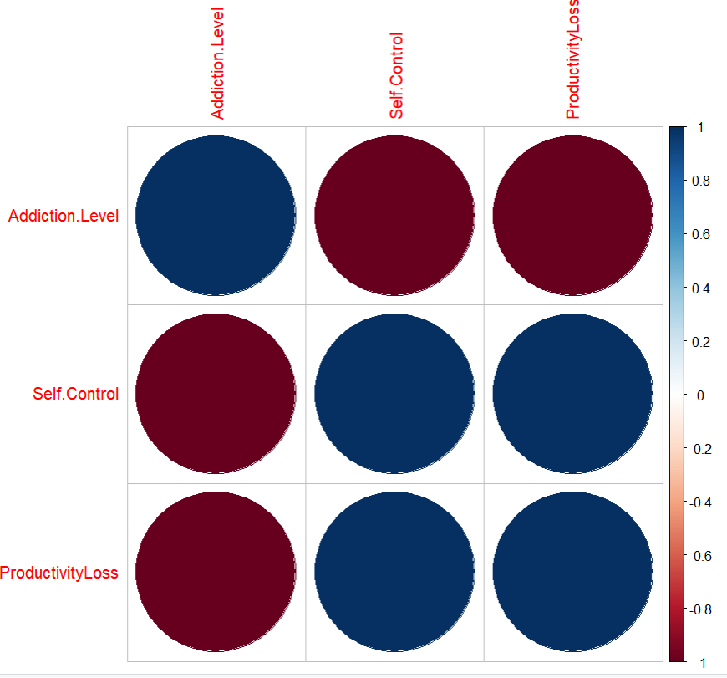

**Relationship Between Addiction Level and Social Media Usage Frequency**

* The scatter plot compares *Addiction Level* (y-axis) to *Frequency of Social Media Use* (x-axis) across different times of day: *Afternoon, Evening, Morning, and Night*.
* *Addiction Level* ranges from 0 to 8
* Addiction levels vary within each time period, with data points appearing at multiple levels for some periods.
* This visualization helps observe potential differences in addiction levels based on time of day and frequency of social media use.

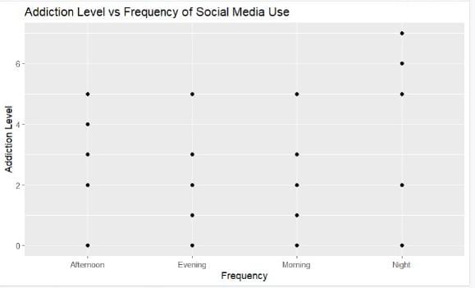

**Predicting Social Media Addiction: A Linear Regression Approach**

**Self-Control** has a significant negative impact on addiction level (p-value < 2e-16), suggesting that individuals with higher self-control are less likely to develop social media addiction.

**Productivity Loss** shows no significant effect on addiction levels (p-value = 0.972), indicating that reduced productivity does not correlate with higher addiction in this dataset

**Frequency of Use** (Evening, Morning, Night) does not significantly impact addiction levels, as the p-values for these periods are all above 0.05, suggesting that the time of day does not strongly influence addiction levels.

**Analyzing Factors Affecting Mental Health and Social Media Addiction**

Model results will help see which factors most affect mental health (i.e., Addiction Level)data$EstimatedEarnings <- data$Engagement * 0.1

* The model results highlight which factors most influence mental health, specifically the Addiction Level.
* A new variable, Estimated Earnings, is calculated using the formula: EstimatedEarnings = Engagement * 0.1
* A new variable, Estimated Earnings, is calculated using the formula: EstimatedEarnings = Engagement * 0.1
* This calculation assumes a relationship between engagement and potential earnings, helping to quantify the impact of social media engagement.
* By incorporating Estimated Earnings, the analysis provides insights into how engagement levels might relate to other variables, such as Addiction Level and Self-Control
* **Impact of Social Media Engagement on Estimated Earnings**
* The highest frequency of earnings occurs at the lower end (0-100) and mid-range (450-500), suggesting that many social media users or influencers earn relatively modest amounts or fall into a middle tier of earnings.
* There is an even distribution of earnings across the entire range, with no single group significantly out-earning others. This suggests that while some users may be highly engaged, their earnings are not drastically higher than those of less engaged users.
* Fluctuations in frequency** indicate that earnings rise and fall across the range, meaning that engagement does not necessarily guarantee high or stable earnings. Users with similar levels of engagement may still experience significantly different earning outcomes.
* Overall, the histogram suggests that social media engagement can lead to a wide range of financial outcomes, with only a few users achieving higher earnings, while many remain in the lower to moderate earning brackets.

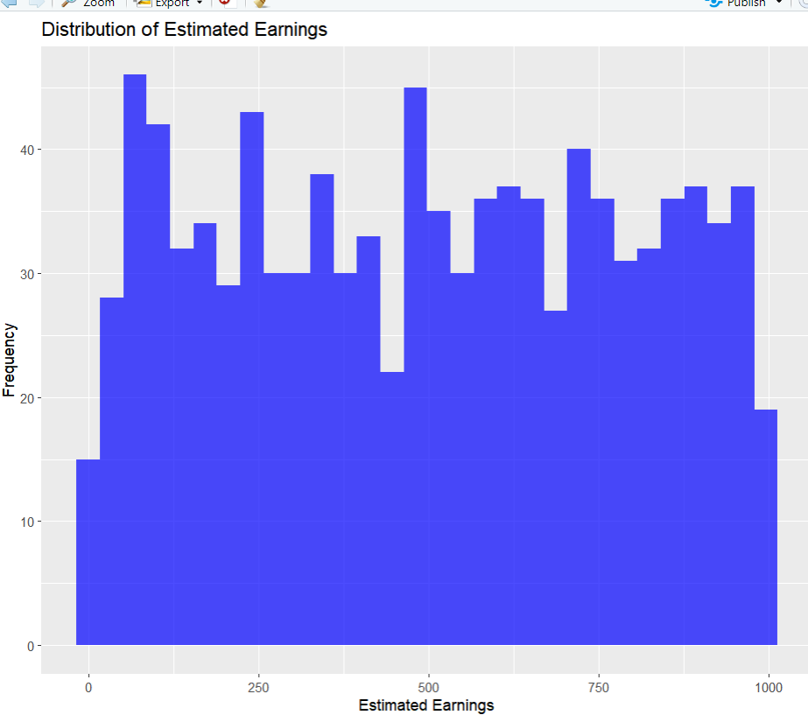

**Analyzing the Impact of Engagement on Estimated Earnings**

* The graph is a scatter plot illustrating the relationship between Engagement (x-axis) and **Estimated Earnings (y-axis).
* There is a strong positive linear correlation between Engagement and Estimated Earnings, indicating that as Engagement increases, Estimated Earnings also increase.
* The data points are clustered closely around a straight line, demonstrating a strong relationship between the two variables.
* This suggests a direct and significant association between Engagement and Estimated Earnings in the dataset.
* Generally, higher levels of Engagement are associated with higher Estimated Earnings.

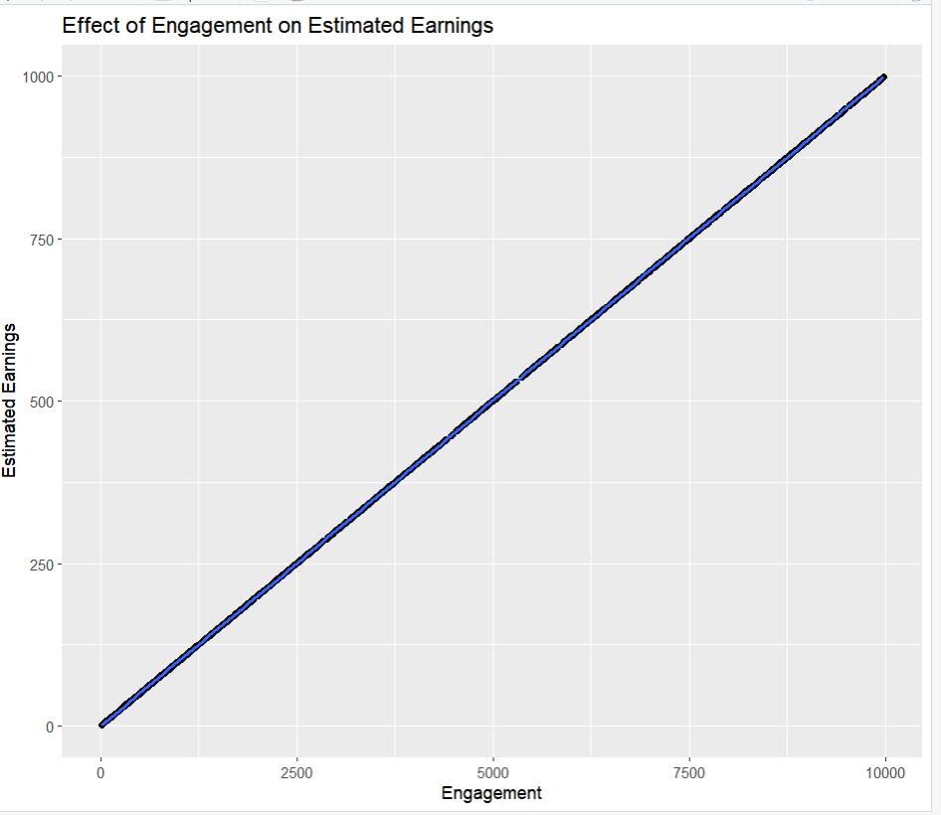

**Modeling Estimated Earnings: Predicting Based on Engagement, Video Length, and Platform**

A linear regression model that aims to predict Estimated Earnings based on three independent variables: Engagement, Video.Length, and Platform.

Key Findings:

* Engagement is the primary driver of Estimated Earnings: The coefficient for Engagement is highly significant (p-value < 2e-16) and positive, indicating that as Engagement increases, Estimated Earnings are also likely to increase.
* Video.Length and Platform are not significant predictors: The coefficients for Video.Length and the different platform categories (Instagram, Tik Tok, YouTube) are not statistically significant, suggesting that they do not have a significant impact on Estimated Earnings after accounting for Engagement.
* Model Fit: The model exhibits a very high R-squared value of 1, indicating that it explains 100% of the variance in Estimated Earnings. However, this might suggest overfitting, and the model's performance should be evaluated on a new dataset.

In summary, the model suggests that Engagement is the key factor influencing Estimated Earnings, while Video.Length and Platform do not have significant predictive power. It's important to interpret these findings cautiously and consider potential limitations, such as overfitting and the potential impact of other variables not included in the model.

**Mental health analysis: Predict Addiction Level or Self Control**

**Key Findings:**

* Model Performance - The model achieved a Root Mean Squared Error (RMSE) of 0.2009657, indicating a relatively low average prediction error.
* An R-squared value of 0.9903757 suggests that the model explains a large portion of the variance in Addiction Level.
* The **Mean Absolute Error (MAE) of 0.1002265 indicates that the average absolute prediction error is also relatively low.
* Predictor Importance - While specific coefficients for each predictor are not explicitly shown, the overall model performance indicates that the combination of **Total Time Spent**, **Number of Sessions**, **Productivity Loss**, and **Satisfaction** provides a good fit for predicting Addiction Level.
* In summary, the model demonstrates **strong predictive performance** for Addiction Level based on the given predictors.
* **Model Summary**
* **Key Findings:**
* A linear regression model predicting an unspecified outcome variable based on Total Time Spent, Number of Sessions, Productivity Loss, and Satisfaction.
* R-squared value of 0.9899 suggests the model explains a large portion of the variance in the outcome variable.
* Adjusted R-squared of 0.9899 indicates model performance is not significantly affected by the number of predictors.
* Predictor Importance - Total Time Spent and Productivity Loss are statistically significant predictors (p-values < 0.001).
* Number of Sessions is not significant, indicating no substantial effect on the outcome variable after accounting for other predictors.
* Satisfaction has a coefficient of NA, likely due to removal from the model for multicollinearity or other issues.
* In summary, the model shows strong predictive performance based on Total Time Spent and Productivity Loss, but further analysis is needed to explore the relationships between these predictors and the outcome variable, as well as consider other unexamined variables.

# **PSYCHOLOGICAL AND BEHAVIOURAL IMPACTS OF SOCIAL MEDIA ENGAGEMENT**

Social media significantly impacts users’ psychology and behavior. Three key theories—Social Comparison Theory, Addiction Theory, and Cognitive Load Theory—help explain these effects.

1. **Social Comparison Theory:** This theory suggests people evaluate themselves by comparing with others. On social media, this often leads to "upward comparisons" (comparing with people perceived as better), which can harm self-esteem and mental health. High Scroll Rates and Addiction Levels in the data indicate that constant comparisons may lead to increased anxiety, productivity loss, and dissatisfaction.
2. **Addiction Theory:** Social media addiction resembles substance addiction, driven by dopamine release and reward-seeking behavior. The data shows Addiction Level correlates with Watch Time and Productivity Loss, suggesting compulsive use disrupts daily life and focus. High Addiction Levels linked to reasons like "Entertainment" or "Procrastination" hint that social media is used as a coping mechanism, often with negative effects.
3. **Cognitive Load Theory:** Social media's continuous stream of content increases cognitive load, overwhelming mental capacity. High Scroll Rates and Watch Time suggest mental fatigue and reduced productivity due to information overload, as users struggle to focus and process constant input.

Understanding these theories in relation to data can guide healthier social media practices, encouraging mindful consumptionand reduced screen time for better mental health and productivity.

# **RECOMMENDATIONS FOR MITIGATING NEGATIVE IMPACTS OF SOCIAL MEDIA**

To help address the psychological and behavioural impacts of social media, the following actionable recommendations focus on limiting excessive use, encouraging mindful engagement, and promoting digital wellness.

1. **Set Time Limits:**
   * Daily Time Restrictions: Encourage users to set daily limits on social media usage. Platforms can offer personalized reminders once usage exceeds a specified amount of time.
   * Bedtime Cut-offs: Introduce features that automatically reduce notifications and limit access to non-essential apps an hour before bed to improve sleep quality.
2. **Enable Digital Wellness Features:**
   * Screen Time Tracking: Platforms can include easy-to-view usage statistics to make users aware of their time spent on the app.
   * Weekly Usage Reports: Send a summary of weekly usage trends, highlighting patterns in productivity loss or addiction-level behaviors, encouraging users to reflect on their habits.
3. **Encourage Mindful Content Consumption:**
   * Mindful Scrolling Reminders: Introduce periodic pop-up messages reminding users to engage with content intentionally, rather than scrolling passively.
   * Limit "Infinite Scroll" Features: Offer the option to disable infinite scrolling, so users can choose to see a finite amount of content, reducing the tendency to over-consume.
4. **Incorporate Positive Reinforcement for Breaks:**
   * Reward System for Taking Breaks: Introduce a points or reward system for users who take breaks from the platform, incentivizing them to reduce screen time.
   * Encouragement Messages: Provide gentle reminders encouraging users to take short breaks after a certain period of continuous usage.
5. **Promote Digital Literacy and Self-Care:**
   * Educational Content on Digital Wellness: Share articles or tips about healthy digital habits and the psychological impact of social media on mental health.
   * Regular Prompts for Goal Setting: Encourage users to set wellness goals related to their screen time and content engagement, with prompts to check on their progress.
6. **Implement Content Filters to Reduce Cognitive Load:**
   * Customizable Feed Settings: Allow users to filter the types of content they see, focusing on what aligns with their personal interests or goals.
   * "Quiet Mode" for Limited Notifications: Offer a "quiet mode" that reduces notifications to only essential ones during work hours or personal time, reducing interruptions and cognitive overload.
7. **Integrate Social Media Detox Challenges:**
   * Host Community Challenges: Organize events like "Digital Detox Days," encouraging groups of users to participate in reducing screen time together.
   * Achievement Badges for Reduced Use: Award users with badges for successfully limiting social media usage or for participating in detox challenges, creating a sense of accomplishment.
8. **Develop Partnerships with Mental Health Apps:**
   * Integrated Break Suggestions: Partner with mental health apps that can suggest mindfulness exercises or meditation prompts to users as part of their breaks.
   * Self-Care Resources: Offer links to mental health and self-care resources within the platform to support users who struggle with overuse and addiction.

These recommendations can help platforms foster healthier online environments, supporting user well-being by encouraging intentional, mindful, and balanced social media use.

# **LIMITATIONS OF THE STUDY**

This study provides valuable insights into the psychological and behavioral impacts of social media use, but certain limitations should be acknowledged to ensure a transparent understanding of the findings and their implications.

1. **Sample Bias:**
   * Demographic Representation: The sample may not fully represent diverse demographics, such as age groups, socioeconomic backgrounds, or cultural differences. This could limit the ability to generalize findings across all social media users.
   * Platform-Specific Bias: Data may be skewed toward users of specific platforms, leading to insights that might not apply universally to all social media environments.
2. **Data Constraints:**
   * Self-Reported Data: Some aspects of the study rely on self-reported data, which can be influenced by social desirability bias or inaccurate recall. Users may underreport or overreport their social media usage and its effects on their well-being.
   * Incomplete Behavioral Metrics: Certain behavioral indicators, such as time spent on specific types of content, are challenging to track accurately and may not capture the full scope of user engagement patterns.
3. **Generalizability Issues:**
   * **Cultural Variations:** The findings might not apply to users from different cultural contexts where social media usage patterns and societal norms differ, potentially affecting how these platforms impact users’ mental health and behaviours.
   * **Temporal Changes:** Social media platforms continuously evolve, and user behaviours change in response. Findings from this study may not remain relevant if platforms introduce new features or if user engagement shifts significantly over time.
4. **Limited Psychological Measures:**
   * Narrow Focus on Behavioural Metrics: While behavioural data provides valuable insights, it may not fully capture the complexity of psychological impacts. Factors such as underlying mental health conditions or social support systems, which can influence social media’s effects on users, are not thoroughly examined in this study.
   * Lack of Longitudinal Data: Without long-term data, this study primarily captures short-term correlations rather than causations, making it difficult to determine long-term psychological impacts or behavioral trends.
5. **Technical Constraints:**
   * Data Accuracy and Reliability: Variability in data collection methods and device limitations could affect the accuracy of data on engagement metrics, addiction levels, and productivity loss.
   * **Limited Control Over External Factors:** Factors like internet speed, device usability, or offline social interactions are not controlled for, which could influence user behaviours in ways not accounted for in the data.

Acknowledging these limitations provides context to the study’s conclusions and highlights areas where future research could enhance the reliability and applicability of findings on social media’s impact on users' mental and behavioural well-being**.**

# **CONCLUSION**

This study highlights the significant psychological and behavioural impacts of social media usage, supported by theories like Social Comparison Theory, Addiction Theory, and Cognitive Load Theory. Our findings indicate that high levels of social media engagement can contribute to productivity loss, increased comparison, and potential addiction behaviors. These effects underscore the need for users to exercise self-regulation and for platforms to implement digital wellness features that promote healthy engagement. By identifying usage patterns, addiction indicators, and their impact on productivity, the study provides insights that could inform interventions aimed at mitigating negative outcomes associated with excessive social media use.

However, it is essential to acknowledge limitations such as sample bias, data constraints, and generalizability issues that may affect the interpretation of results. Further research incorporating diverse populations and longitudinal data is recommended to understand the long-term effects of social media use comprehensively. With careful consideration of these insights and limitations, stakeholders can develop strategies to foster a more balanced and mindful approach to social media engagement.

**References**

1. Festinger, L. (1954). *A Theory of Social Comparison Processes.* Human Relations, 7(2), 117–140.
2. Griffiths, M. D. (2005). *A ‘Components’ Model of Addiction within a Biopsychosocial Framework.* Journal of Substance Use, 10(4), 191-197.

These references provide foundational support for understanding the psychological theories and behavioural impacts analyzed in this study, contributing to a well-rounded perspective on social media's influence on mental health and productivity.

**Submitted By:** Jiya Patel

Sakshi Singh

Maitri Chopda

**Submitted To:** Dr. Sheetal Shende